The User Manual of GrainD

# Introduction：

GrainD is an image segmentation software for SEM and AFM images of polycrystalline films for the identification, segmentation, counting and statistics of grains in images. Through this software, users can explore the grain distribution characteristics and rules of organic and inorganic hybrid perovskite and other polycrystalline films, assisting the study of perovskite film formation characteristics, mechanism, and related device performance.

This software is developed by Fujian Normal University and Strait Laboratory of Flexible Electronics

(SLoFE), Fuzhou 350117, China.

**Contact:**

Deli Li, Fujian Normal University.

Email：[ifedlli@fjnu.edu.cn](mailto:ifedlli@fjnu.edu.cn)

**Basic reference:** S. Yang, S. Qing, L. Chao, D. Li, Y. Wang, *Adv. Theory Simul.* 2024, ***7(2)***, 2300619. doi.org/10.1002/adts.202300619

# User interface and functional modules

* Overview of GrainD

The GrainD user interface consists of six function modules, which are “File”, “Original image”, “Initial Segmentation”, “Secondary Treatment”, “Grain statistics”, and “Image Segments”.

1. **File**. The modules of “File” is used to import the image to be segmented.
2. **Original image**. The imported image is displayed in “Original image”.
3. **Initial Segmentation**. Initial Segmentation section are used to pre-segment the image.
4. **Secondary Treatment**. Secondary Treatment are used to segment chosen pigment that is not well segmented in the initial segmentation.
5. **Image Segments**. The segmented Image is displayed in the “Image Segments” window, and the statistics of image are provided in “Grain statistics”.

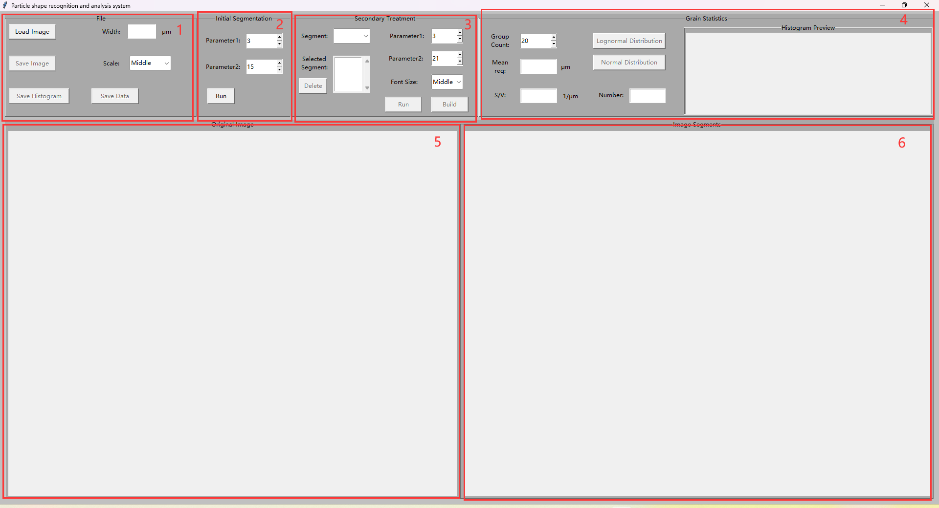

Figure 1.1 User interface.

* The module of “File”

The module of“File”is used to import and save data, including “Load Image”, “Width”, “Scale”, “Save Histogram”, “Save Data”, “Save Image”.

Figure 1.2 The module of “File”.

1. The buttons of “Load Image” and “Width” are used to import image buttons to set the actual width of objects in the image. The image formats are “png”, “jpg”, “gif”, and All files.
2. “Scale” sets the grain size in the image, and the value has “Small”, “Middle” and “Large” (If the number of grains in the image is large, selecting large, otherwise Small or Middle).
3. The button of “Save Histogram” is used to save histogram of grain size.
4. The button of “Save Image” is used to save the images which are segmented.
5. The button of “Save Data” is used to save the data of characteristics (size, S/V) of grains.

* The module of “Initial Segmentation”

After importing the image and entering the actual width, adjust the parameters: “Parameter1” adjusts the parameter 1. Parameter 1 affects the recognition of grain edges in the image, and the larger the value, the more obvious the grain boundary details are. However, if parameter 1 is too large, the boundary is too thick. Generally, the value ranges from 5 to 8. Parameter2 Adjustment parameter 2. The value of control parameter 2 can separate the two grains with adhered edges, and the larger the value, the more the two grains can be separated. However, a large value of parameter 2 will cause the shape of the segmentation result to change, and the value is generally 15-35.

Figure 1.3 The module of “Initial Segmentation”

* The module of “Secondary Treatment”

Area 3 is the secondary adjustment/segmentation area. Where, “Segment” is the number of the grain to be selected for secondary segmentation, “Delete” Indicates the number of the selected area. Parameter1 and Parameter2 functions are the same as those in area 2. “Font Size” Indicates the numbered font size, which can be divided into three levels: Little, Middle, and Large. “Run” indicates the secondary segment button to start running. “Build” is the button that confirms the result of the secondary segment.

Figure 1.4 The module of “Secondary Treatment”

* The module of “Grain Statistics”

The module of “Grain Statistics” is the statistics of grain area. “Group Count” controls the number of groups in the statistical histogram of output distribution. “Mean req” output value is the average equivalent radius of all grains. “S/V” outputs the value of S/V. “Number” outputs the statistical number of grains. “Lognormal Distribution” is the button of output Lognormal fitting curve distribution histogram. “Normal Distribution” is button of the output Normal fitting curve distribution histogram.

Figure 1.5 The module of “Grain Statistics”

* The modules of “Original image” and “Image Segments”

The module of “Original image” is the area of the showing of imported original image.

Figure 1.6 The module of “Original image”

The module of “Image Segments” is the area of showing of segmenting result.

Figure 1.7 The module of “Image Segments”

# Operating steps：

GrainD can obtain the segmented image and statistics of grain size in a few simple steps. At the same time, users can also monitor the segmentation effect in real time during the segmentation process. In summary, the complete process of segmenting an image is divided into the following steps:

1. Loading image
2. Setting up parameters
3. Initial segmentation (Pre-segmentation)
4. Secondary segmentation (Precise segmentation)
5. Checking the statistics of grain
6. Saving results
7. **Loading image**

Click “Load Image” to select the image you want to segment. The format of the loaded image is: png、jpg、gif and All files.

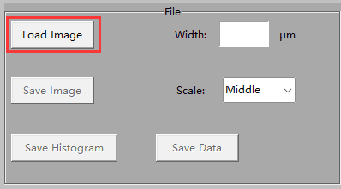

Figure 1.1 Clicking “Load Image”.

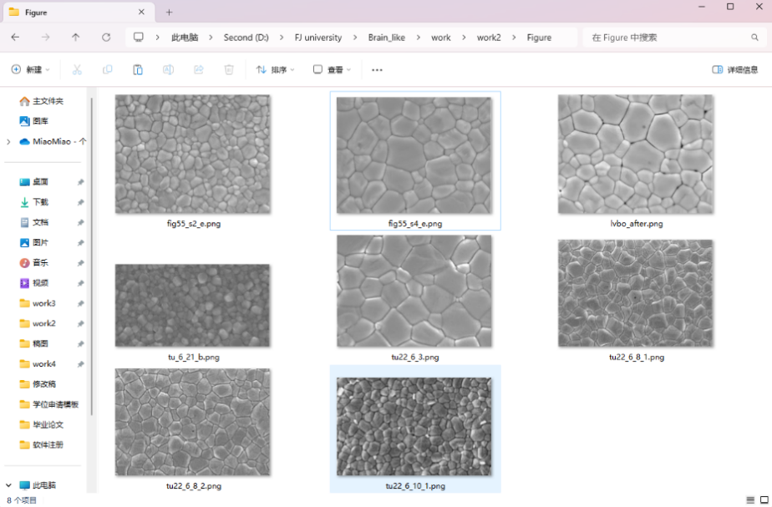

Figure 1.2 Selecting the image you want to segment.

Figure 1.3 The loaded image will be shown in the “original image”.

1. **Setting up parameters**

Entering the “width”, in µm. Note: The value entered is the true width of the film in order to calculate the actual size of the grain. The modified parameters are used to correctly calculate the grain statistics in the picture.

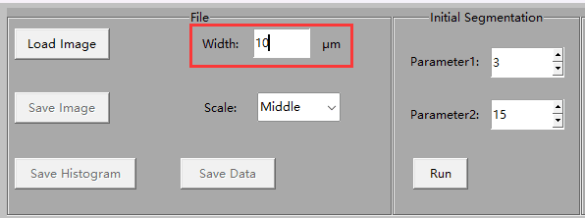

Figure 2.1 Entering the actual width of 10µm.

1. **Initial segmentation**

Entering “Parameter1” and “Parameter2”. “Parameter1” controls the first parameter. Parameter1 affects the recognition of grain edge in the image, and the larger the value, the more obvious the grain boundary details. However, if parameter 1 is too large, the boundary is too thick. Generally, the value ranges from 5 to 8. Parameter2 adjustment the second parameter. The value of control parameter 2 can separate the two grains with adhered edges, and the larger the value, the more the two grains can be separated. However, a large value of parameter 2 will cause the shape of the segmentation result to change.

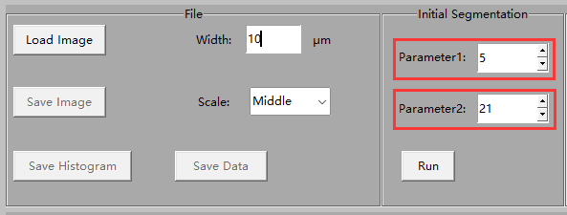

Figure 2.2 Setting up the parameters.

Clicking the “run”，and waiting for the result of segmenting. The result is displayed in the right blank area “Image Segments”, and the preview of the distribution histogram of grain size is displayed in the upper right corner.

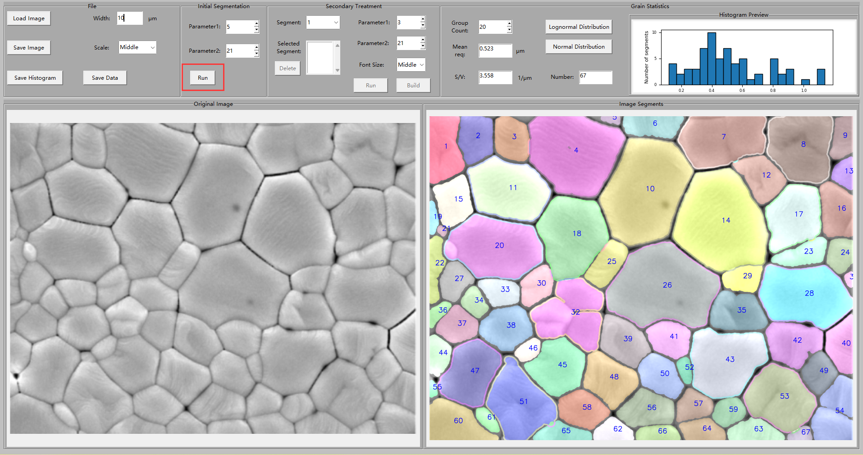

Figure 3.1 The results of initial segmentation,

1. **Secondary segmentation**

The role of secondary segmentation is to divide the undivided areas, as shown in numbers 54 and 32.

1. Selecting the number which areas are undivided. In “segment”, selecting the number of the undivided areas (It’s better to select one number at a time).

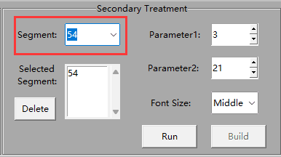

Figure 4.1 Selecting the number of undivided areas. There is number of 54.

1. Adjusting the parameters of secondary segmentation.

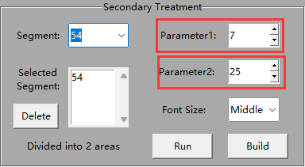

Figure 4.2 Adjusting the parameters to 7 and 25.

1. Click “Run” to start secondary segmentation. As you can see, area 54 has been segmented from one area to two. If you find that the original area is not divided into multiple areas after running, you can adjust the parameters and continue to click Run to finish secondary segmentation.

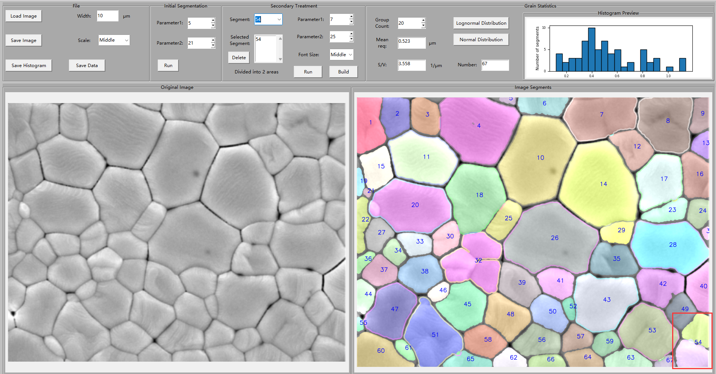

Figure 4.3 The result of secondary segmentation.

1. When you think the effect of segmentation is OK, clicking “Build” to confirm the result of the secondary segmentation. It will number the new area that is divided. After the second division is confirmed, the second division of other areas can be continued. After running the secondary segmentation, you need to click “Build” to update the information. (Such as histogram distribution, average size, etc.)

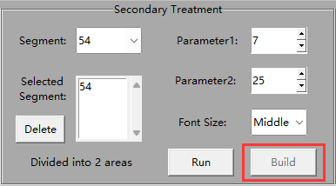

Figure 4.4 Clicking “Build” to confirm secondary segmentation.

电脑萤幕画面

Figure 4.5 After confirming the segmentation, the new segmented areas are renumbered.

1. **Checking the statistics of grain**

Users can view the Statistics of grain in the "Grain Statistics" module, including “Mean req” (mean radius), “Number” (quantity), “S/V” (specific surface area) and other statistics.

The following figure illustrates the grain statistics in an image containing 68 grains with an average radius of 0.519 microns and a specific surface area of 3.586 per micron.

Figure 5.1 The Statistics of grain in the "Grain Statistics" module.

1. Selecting the number of groups of the square distribution to control the group number of histogram. Here we chose 10.

Figure 5.2 “Group Count” can control the group number of histogram.

1. Clicking “Lognormal Distribution” to see the Lognormal fit for the distribution. “s” and “u” in the figure are the two fitting parameters "σ and μ of the lognormal distribution formula. The fitting formula is：

$$f\left(x\right)=\frac{A}{\sqrt{2π}σx}e^{−\frac{{\left(lnx−μ\right)}^{2}}{2σ^{2}}} (1)$$

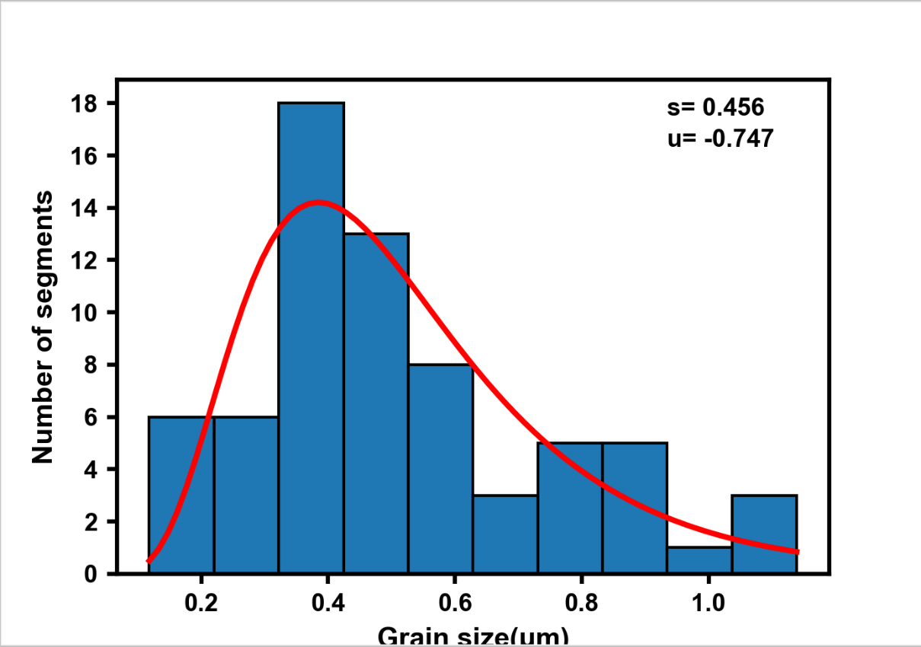

Figure 5.3 The result of Lognormal Distribution

1. Clicking “Normal Distribution” to view the Normal Distribution result. The “Std” in the figure is the standard deviation. The fitting formula is：

Figure 5.4 The result of Normal Distribution.

1. **Saving results**

Data can be saved by the “File” module. “Save Image” saves the result of segmented image. “Save Histogram” saves the distribution histogram. “Save Data” saves the information of each grain (such as the grain size and corresponding number, average size, etc.).

Figure 6.1 The module of “File”.

Attachment 1

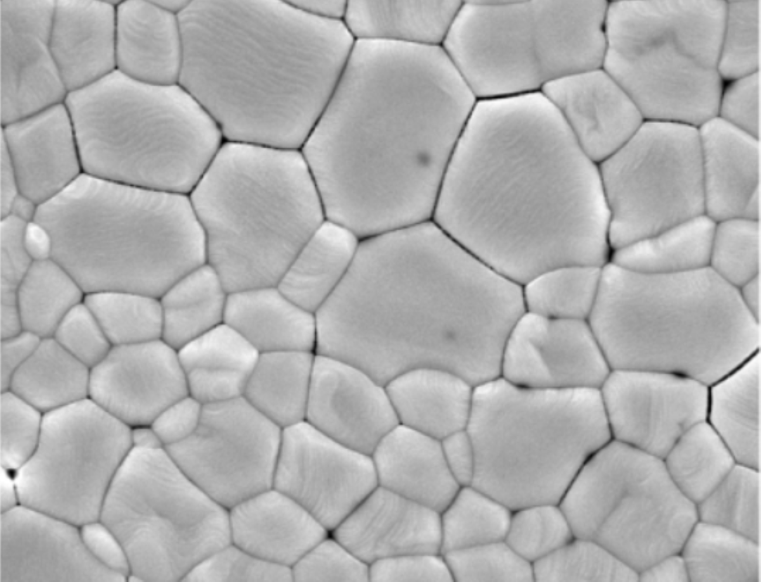

Attached Figure 1.